1 run......

Downloading: 100%

464/464 [00:00<00:00, 17.2kB/s]

Downloading: 100%

270M/270M [00:06<00:00, 45.9MB/s]

training 1 epoch...

64.47306060791016 seconds used......

1 training finished! average train loss: 1.7094675190945998

total clf loss: 166.024504840374 total adv loss: 76.82296057417989

evaluating...

Confusion matrix, without normalization

[[ 213 74 486]

[ 59 124 247]

[ 95 57 2177]]

Normalized confusion matrix

[[0.27554981 0.09573092 0.62871928]

[0.1372093 0.28837209 0.5744186 ]

[0.04079004 0.02447402 0.93473594]]

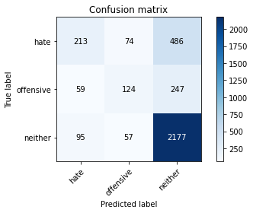

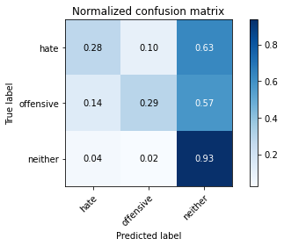

precision recall f1-score support

hate 0.58 0.28 0.37 773

offensive 0.49 0.29 0.36 430

neither 0.75 0.93 0.83 2329

accuracy 0.71 3532

macro avg 0.60 0.50 0.52 3532

weighted avg 0.68 0.71 0.67 3532

average eval_loss: 0.7158628243342632, accuracy: 0.7117780294450736

training 2 epoch...

63.659629344940186 seconds used......

2 training finished! average train loss: 1.2112373368625335

total clf loss: 116.47147236764431 total adv loss: 55.014954917132854

evaluating...

Confusion matrix, without normalization

[[ 329 101 343]

[ 85 169 176]

[ 173 129 2027]]

Normalized confusion matrix

[[0.42561449 0.13065977 0.44372574]

[0.19767442 0.39302326 0.40930233]

[0.07428081 0.05538858 0.87033061]]

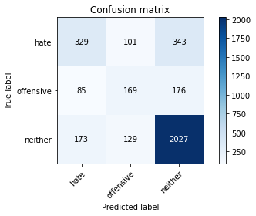

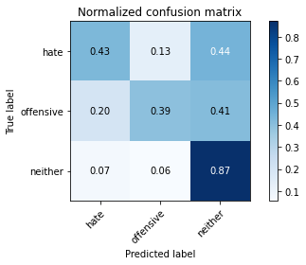

precision recall f1-score support

hate 0.56 0.43 0.48 773

offensive 0.42 0.39 0.41 430

neither 0.80 0.87 0.83 2329

accuracy 0.71 3532

macro avg 0.59 0.56 0.57 3532

weighted avg 0.70 0.71 0.70 3532

average eval_loss: 0.6963502160236661, accuracy: 0.7148924122310306

training 3 epoch...

63.53806161880493 seconds used......

3 training finished! average train loss: 0.7361479794437235

total clf loss: 79.33406393229961 total adv loss: 29.162804109975696

evaluating...

Confusion matrix, without normalization

[[ 353 86 334]

[ 89 159 182]

[ 216 98 2015]]

Normalized confusion matrix

[[0.45666235 0.11125485 0.43208279]

[0.20697674 0.36976744 0.42325581]

[0.09274367 0.04207815 0.86517819]]

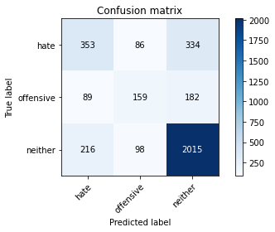

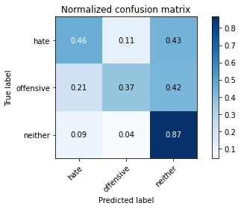

precision recall f1-score support

hate 0.54 0.46 0.49 773

offensive 0.46 0.37 0.41 430

neither 0.80 0.87 0.83 2329

accuracy 0.72 3532

macro avg 0.60 0.56 0.58 3532

weighted avg 0.70 0.72 0.70 3532

average eval_loss: 0.7547696438212853, accuracy: 0.7154586636466591

training 4 epoch...

63.62469291687012 seconds used......

4 training finished! average train loss: 0.3810200501970429

total clf loss: 50.160214737057686 total adv loss: 10.545267349487403

evaluating...

Confusion matrix, without normalization

[[ 348 118 307]

[ 87 180 163]

[ 200 148 1981]]

Normalized confusion matrix

[[0.45019405 0.15265201 0.39715395]

[0.20232558 0.41860465 0.37906977]

[0.08587377 0.06354659 0.85057965]]

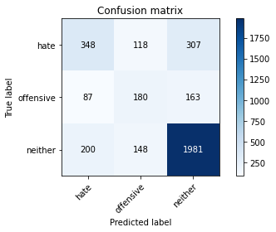

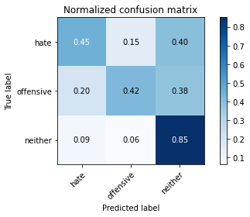

precision recall f1-score support

hate 0.55 0.45 0.49 773

offensive 0.40 0.42 0.41 430

neither 0.81 0.85 0.83 2329

accuracy 0.71 3532

macro avg 0.59 0.57 0.58 3532

weighted avg 0.70 0.71 0.70 3532

average eval_loss: 0.8555620711738781, accuracy: 0.7103624009060022

training 5 epoch...

63.6747612953186 seconds used......

5 training finished! average train loss: 0.22359850369194612

total clf loss: 33.29824706912041 total adv loss: 4.257336593775108

evaluating...

Confusion matrix, without normalization

[[ 322 116 335]

[ 88 177 165]

[ 182 140 2007]]

Normalized confusion matrix

[[0.41655886 0.15006468 0.43337646]

[0.20465116 0.41162791 0.38372093]

[0.07814513 0.06011164 0.86174324]]

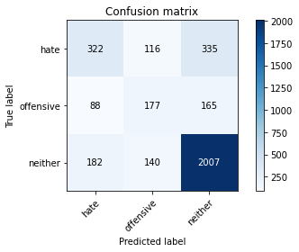

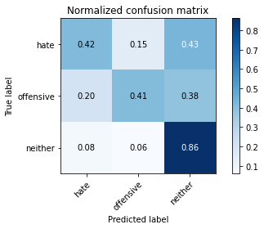

precision recall f1-score support

hate 0.54 0.42 0.47 773

offensive 0.41 0.41 0.41 430

neither 0.80 0.86 0.83 2329

accuracy 0.71 3532

macro avg 0.58 0.56 0.57 3532

weighted avg 0.70 0.71 0.70 3532

average eval_loss: 0.9616437031555984, accuracy: 0.7095130237825594

training 6 epoch...

63.880473613739014 seconds used......

6 training finished! average train loss: 0.18124608052047816

total clf loss: 24.864929312840104 total adv loss: 4.514043829367438

evaluating...

Confusion matrix, without normalization

[[ 379 91 303]

[ 115 164 151]

[ 244 127 1958]]

Normalized confusion matrix

[[0.49029754 0.11772316 0.3919793 ]

[0.26744186 0.38139535 0.35116279]

[0.10476599 0.05452984 0.84070416]]

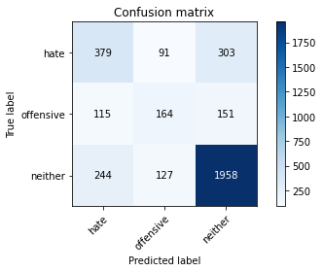

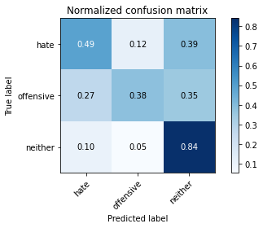

precision recall f1-score support

hate 0.51 0.49 0.50 773

offensive 0.43 0.38 0.40 430

neither 0.81 0.84 0.83 2329

accuracy 0.71 3532

macro avg 0.58 0.57 0.58 3532

weighted avg 0.70 0.71 0.70 3532

average eval_loss: 1.0374921456737034, accuracy: 0.7080973952434881

training 7 epoch...

63.662240505218506 seconds used......

7 training finished! average train loss: 0.10370937482837368

total clf loss: 14.923429698683321 total adv loss: 2.2351117159823843

evaluating...

Confusion matrix, without normalization

[[ 425 63 285]

[ 150 122 158]

[ 293 92 1944]]

Normalized confusion matrix

[[0.54980595 0.08150065 0.3686934 ]

[0.34883721 0.28372093 0.36744186]

[0.12580507 0.03950193 0.834693 ]]

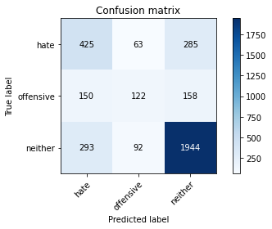

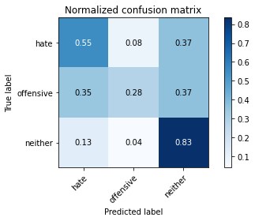

precision recall f1-score support

hate 0.49 0.55 0.52 773

offensive 0.44 0.28 0.35 430

neither 0.81 0.83 0.82 2329

accuracy 0.71 3532

macro avg 0.58 0.56 0.56 3532

weighted avg 0.70 0.71 0.70 3532

average eval_loss: 1.176917563471417, accuracy: 0.7052661381653454

training 8 epoch...

63.598114252090454 seconds used......

8 training finished! average train loss: 0.09388978426459241

total clf loss: 11.339370205067098 total adv loss: 3.1090097585208696

evaluating...

Confusion matrix, without normalization

[[ 378 72 323]

[ 124 133 173]

[ 226 98 2005]]

Normalized confusion matrix

[[0.48900388 0.0931436 0.41785252]

[0.28837209 0.30930233 0.40232558]

[0.09703736 0.04207815 0.8608845 ]]

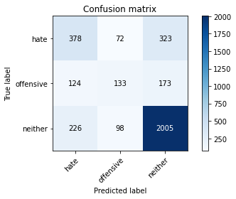

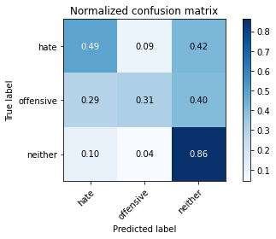

precision recall f1-score support

hate 0.52 0.49 0.50 773

offensive 0.44 0.31 0.36 430

neither 0.80 0.86 0.83 2329

accuracy 0.71 3532

macro avg 0.59 0.55 0.57 3532

weighted avg 0.70 0.71 0.70 3532

average eval_loss: 1.2253137035558452, accuracy: 0.7123442808607021

training 9 epoch...

63.634828090667725 seconds used......

9 training finished! average train loss: 0.0755693443507992

total clf loss: 8.579879936063662 total adv loss: 2.775793791649221

evaluating...

Confusion matrix, without normalization

[[ 365 57 351]

[ 121 116 193]

[ 163 84 2082]]

Normalized confusion matrix

[[0.47218629 0.07373868 0.45407503]

[0.28139535 0.26976744 0.44883721]

[0.06998712 0.03606698 0.8939459 ]]

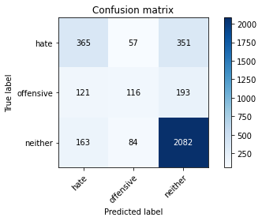

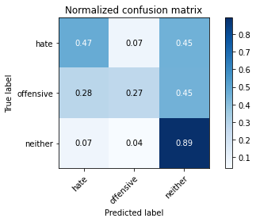

precision recall f1-score support

hate 0.56 0.47 0.51 773

offensive 0.45 0.27 0.34 430

neither 0.79 0.89 0.84 2329

accuracy 0.73 3532

macro avg 0.60 0.55 0.56 3532

weighted avg 0.70 0.73 0.71 3532

average eval_loss: 1.314391950176934, accuracy: 0.7256511891279728

training 10 epoch...

63.66137075424194 seconds used......

10 training finished! average train loss: 0.051729465444462705

total clf loss: 5.762920471606776 total adv loss: 1.9552448127253683

evaluating...

Confusion matrix, without normalization

[[ 404 80 289]

[ 131 139 160]

[ 263 123 1943]]

Normalized confusion matrix

[[0.52263907 0.10349288 0.37386805]

[0.30465116 0.32325581 0.37209302]

[0.112924 0.05281237 0.83426363]]

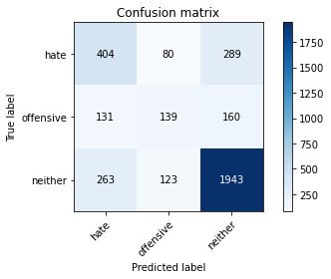

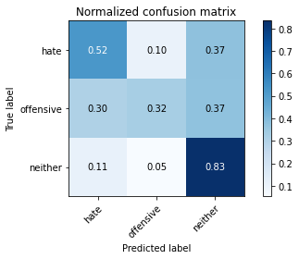

precision recall f1-score support

hate 0.51 0.52 0.51 773

offensive 0.41 0.32 0.36 430

neither 0.81 0.83 0.82 2329

accuracy 0.70 3532

macro avg 0.57 0.56 0.57 3532

weighted avg 0.70 0.70 0.70 3532

average eval_loss: 1.3331515528051192, accuracy: 0.703850509626274

2 run......

training 1 epoch...

63.63337421417236 seconds used......

1 training finished! average train loss: 1.7123172726223175

total clf loss: 162.9493436217308 total adv loss: 78.62699314951897

evaluating...

Confusion matrix, without normalization

[[ 242 68 463]

[ 60 136 234]

[ 82 53 2194]]

Normalized confusion matrix

[[0.31306598 0.08796895 0.59896507]

[0.13953488 0.31627907 0.54418605]

[0.03520824 0.02275655 0.94203521]]

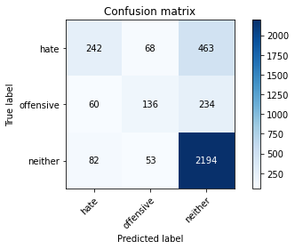

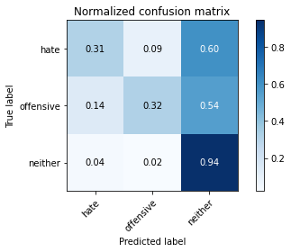

precision recall f1-score support

hate 0.63 0.31 0.42 773

offensive 0.53 0.32 0.40 430

neither 0.76 0.94 0.84 2329

accuracy 0.73 3532

macro avg 0.64 0.52 0.55 3532

weighted avg 0.70 0.73 0.69 3532

average eval_loss: 0.6957399989925536, accuracy: 0.7281993204983013

training 2 epoch...

63.707188844680786 seconds used......

2 training finished! average train loss: 1.177197988020545

total clf loss: 112.33512263000011 total adv loss: 53.90045066922903

evaluating...

Confusion matrix, without normalization

[[ 279 99 395]

[ 65 166 199]

[ 100 101 2128]]

Normalized confusion matrix

[[0.36093144 0.12807245 0.51099612]

[0.15116279 0.38604651 0.4627907 ]

[0.04293688 0.04336625 0.91369687]]

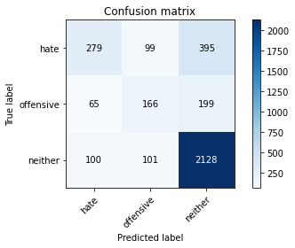

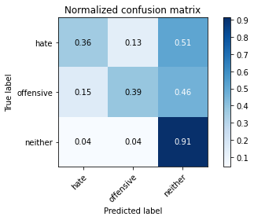

precision recall f1-score support

hate 0.63 0.36 0.46 773

offensive 0.45 0.39 0.42 430

neither 0.78 0.91 0.84 2329

accuracy 0.73 3532

macro avg 0.62 0.55 0.57 3532

weighted avg 0.71 0.73 0.71 3532

average eval_loss: 0.6992881921893459, accuracy: 0.7284824462061155

training 3 epoch...

63.61336064338684 seconds used......

3 training finished! average train loss: 0.7135936056069512

total clf loss: 74.56071639806032 total adv loss: 29.440643879584968

evaluating...

Confusion matrix, without normalization

[[ 312 62 399]

[ 76 147 207]

[ 98 79 2152]]

Normalized confusion matrix

[[0.40362225 0.08020699 0.51617076]

[0.17674419 0.34186047 0.48139535]

[0.04207815 0.03392014 0.92400172]]

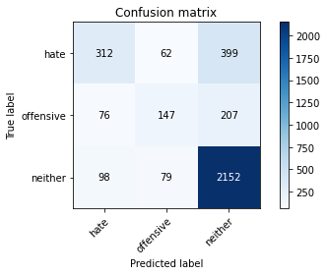

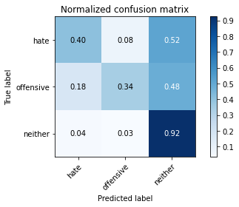

precision recall f1-score support

hate 0.64 0.40 0.50 773

offensive 0.51 0.34 0.41 430

neither 0.78 0.92 0.85 2329

accuracy 0.74 3532

macro avg 0.64 0.56 0.58 3532

weighted avg 0.72 0.74 0.72 3532

average eval_loss: 0.7713077013186143, accuracy: 0.7392412231030577

training 4 epoch...

63.64138340950012 seconds used......

4 training finished! average train loss: 0.3497875374268721

total clf loss: 45.59743716940284 total adv loss: 9.906416167796124

evaluating...

Confusion matrix, without normalization

[[ 351 36 386]

[ 102 100 228]

[ 132 47 2150]]

Normalized confusion matrix

[[0.45407503 0.0465718 0.49935317]

[0.2372093 0.23255814 0.53023256]

[0.05667669 0.02018033 0.92314298]]

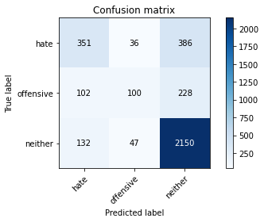

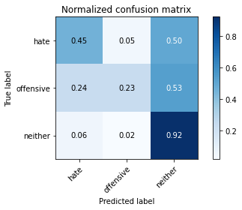

precision recall f1-score support

hate 0.60 0.45 0.52 773

offensive 0.55 0.23 0.33 430

neither 0.78 0.92 0.84 2329

accuracy 0.74 3532

macro avg 0.64 0.54 0.56 3532

weighted avg 0.71 0.74 0.71 3532

average eval_loss: 0.8942327738902663, accuracy: 0.736409966024915

training 5 epoch...

63.61296343803406 seconds used......

5 training finished! average train loss: 0.21222156136829584

total clf loss: 29.50173108652234 total adv loss: 5.091850450669881

evaluating...

Confusion matrix, without normalization

[[ 400 76 297]

[ 107 170 153]

[ 237 112 1980]]

Normalized confusion matrix

[[0.51746442 0.09831824 0.38421734]

[0.24883721 0.39534884 0.35581395]

[0.10176041 0.04808931 0.85015028]]

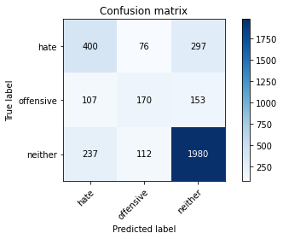

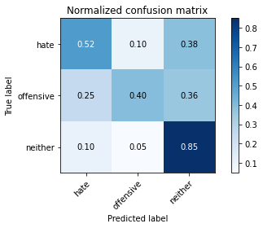

precision recall f1-score support

hate 0.54 0.52 0.53 773

offensive 0.47 0.40 0.43 430

neither 0.81 0.85 0.83 2329

accuracy 0.72 3532

macro avg 0.61 0.59 0.60 3532

weighted avg 0.71 0.72 0.72 3532

average eval_loss: 0.9487446329351199, accuracy: 0.7219705549263873

training 6 epoch...

63.68908429145813 seconds used......

6 training finished! average train loss: 0.16223949554530695

total clf loss: 21.271437655203044 total adv loss: 4.533673986068607

evaluating...

Confusion matrix, without normalization

[[ 333 93 347]

[ 90 167 173]

[ 160 105 2064]]

Normalized confusion matrix

[[0.43078913 0.12031048 0.44890039]

[0.20930233 0.38837209 0.40232558]

[0.06869901 0.04508373 0.88621726]]

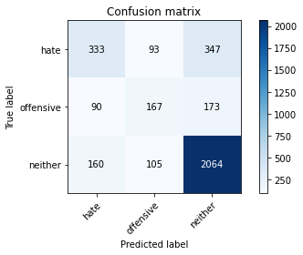

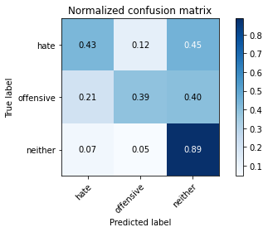

precision recall f1-score support

hate 0.57 0.43 0.49 773

offensive 0.46 0.39 0.42 430

neither 0.80 0.89 0.84 2329

accuracy 0.73 3532

macro avg 0.61 0.57 0.58 3532

weighted avg 0.71 0.73 0.71 3532

average eval_loss: 1.0403584588718953, accuracy: 0.7259343148357871

training 7 epoch...

63.780579566955566 seconds used......

7 training finished! average train loss: 0.08296600270787263

total clf loss: 11.660258991178125 total adv loss: 1.9271917485048107

evaluating...

Confusion matrix, without normalization

[[ 409 104 260]

[ 123 163 144]

[ 255 147 1927]]

Normalized confusion matrix

[[0.52910737 0.13454075 0.33635188]

[0.28604651 0.37906977 0.33488372]

[0.10948905 0.06311722 0.82739373]]

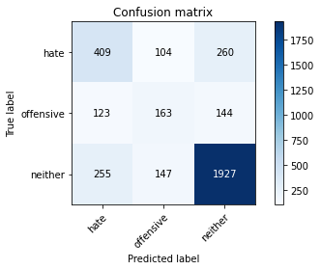

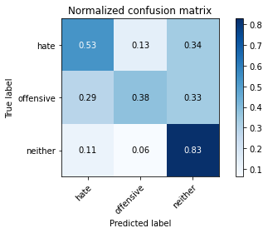

precision recall f1-score support

hate 0.52 0.53 0.52 773

offensive 0.39 0.38 0.39 430

neither 0.83 0.83 0.83 2329

accuracy 0.71 3532

macro avg 0.58 0.58 0.58 3532

weighted avg 0.71 0.71 0.71 3532

average eval_loss: 1.107273920991663, accuracy: 0.7075311438278595

training 8 epoch...

63.73696851730347 seconds used......

8 training finished! average train loss: 0.06467374052882274

total clf loss: 8.245827941922471 total adv loss: 1.9240807631831558

evaluating...

Confusion matrix, without normalization

[[ 378 48 347]

[ 123 117 190]

[ 179 66 2084]]

Normalized confusion matrix

[[0.48900388 0.06209573 0.44890039]

[0.28604651 0.27209302 0.44186047]

[0.07685702 0.02833834 0.89480464]]

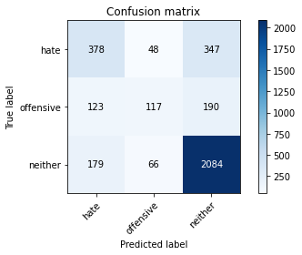

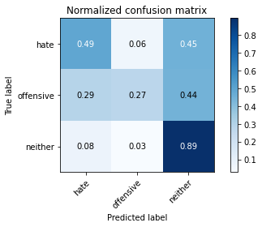

precision recall f1-score support

hate 0.56 0.49 0.52 773

offensive 0.51 0.27 0.35 430

neither 0.80 0.89 0.84 2329

accuracy 0.73 3532

macro avg 0.62 0.55 0.57 3532

weighted avg 0.71 0.73 0.71 3532

average eval_loss: 1.2551187805536776, accuracy: 0.7301812004530012

training 9 epoch...

63.673086166381836 seconds used......

9 training finished! average train loss: 0.08765762435511391

total clf loss: 8.437963691307232 total adv loss: 3.977005946857389

evaluating...

Confusion matrix, without normalization

[[ 416 88 269]

[ 118 166 146]

[ 238 122 1969]]

Normalized confusion matrix

[[0.538163 0.11384217 0.34799483]

[0.2744186 0.38604651 0.33953488]

[0.10218978 0.052383 0.84542722]]

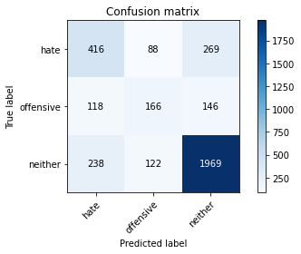

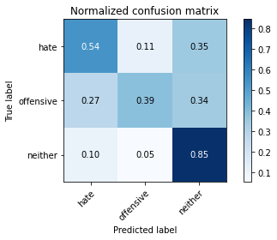

precision recall f1-score support

hate 0.54 0.54 0.54 773

offensive 0.44 0.39 0.41 430

neither 0.83 0.85 0.84 2329

accuracy 0.72 3532

macro avg 0.60 0.59 0.60 3532

weighted avg 0.72 0.72 0.72 3532

average eval_loss: 1.272632360205812, accuracy: 0.7222536806342016

training 10 epoch...

63.63872766494751 seconds used......

10 training finished! average train loss: 0.04147396661169369

total clf loss: 4.474698034930043 total adv loss: 1.640466869865314

evaluating...

Confusion matrix, without normalization

[[ 403 95 275]

[ 119 149 162]

[ 258 112 1959]]

Normalized confusion matrix

[[0.52134541 0.1228978 0.35575679]

[0.27674419 0.34651163 0.37674419]

[0.11077716 0.04808931 0.84113353]]

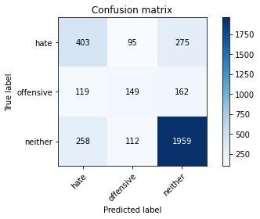

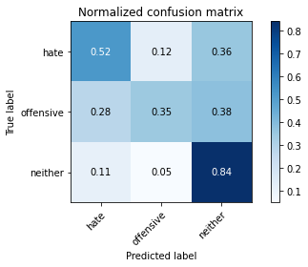

precision recall f1-score support

hate 0.52 0.52 0.52 773

offensive 0.42 0.35 0.38 430

neither 0.82 0.84 0.83 2329

accuracy 0.71 3532

macro avg 0.58 0.57 0.58 3532

weighted avg 0.70 0.71 0.71 3532

average eval_loss: 1.3168699781773454, accuracy: 0.7109286523216308

3 run......

training 1 epoch...

63.70444178581238 seconds used......

1 training finished! average train loss: 1.7383001959897617

total clf loss: 165.88158401846886 total adv loss: 79.59027604013681

evaluating...

Confusion matrix, without normalization

[[ 317 60 396]

[ 87 131 212]

[ 143 73 2113]]

Normalized confusion matrix

[[0.41009056 0.07761966 0.51228978]

[0.20232558 0.30465116 0.49302326]

[0.06139974 0.03134392 0.90725633]]

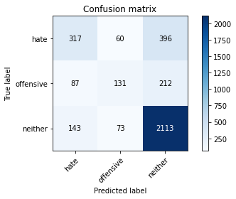

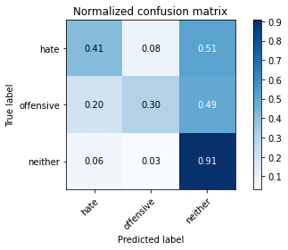

precision recall f1-score support

hate 0.58 0.41 0.48 773

offensive 0.50 0.30 0.38 430

neither 0.78 0.91 0.84 2329

accuracy 0.73 3532

macro avg 0.62 0.54 0.56 3532

weighted avg 0.70 0.73 0.70 3532

average eval_loss: 0.6949971735814197, accuracy: 0.7250849377123443

training 2 epoch...

63.73588299751282 seconds used......

2 training finished! average train loss: 1.2010134901592437

total clf loss: 113.75154536962509 total adv loss: 55.418988920748234

evaluating...

Confusion matrix, without normalization

[[ 293 122 358]

[ 68 189 173]

[ 122 161 2046]]

Normalized confusion matrix

[[0.37904269 0.15782665 0.46313066]

[0.15813953 0.43953488 0.40232558]

[0.052383 0.06912838 0.87848862]]

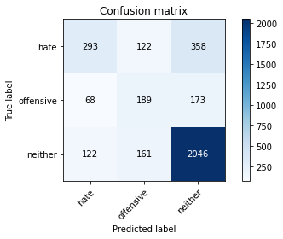

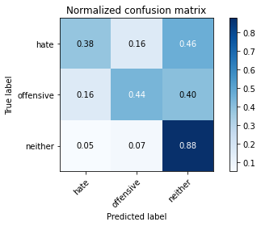

precision recall f1-score support

hate 0.61 0.38 0.47 773

offensive 0.40 0.44 0.42 430

neither 0.79 0.88 0.83 2329

accuracy 0.72 3532

macro avg 0.60 0.57 0.57 3532

weighted avg 0.71 0.72 0.70 3532

average eval_loss: 0.7002511292190875, accuracy: 0.7157417893544734

training 3 epoch...

63.846996784210205 seconds used......

3 training finished! average train loss: 0.7453988291681769

total clf loss: 78.11493526399136 total adv loss: 30.637323025614023

evaluating...

Confusion matrix, without normalization

[[ 336 41 396]

[ 107 112 211]

[ 140 50 2139]]

Normalized confusion matrix

[[0.43467012 0.0530401 0.51228978]

[0.24883721 0.26046512 0.49069767]

[0.06011164 0.02146844 0.91841992]]

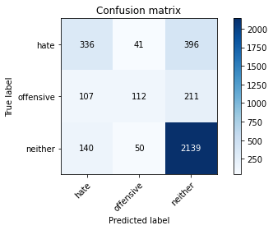

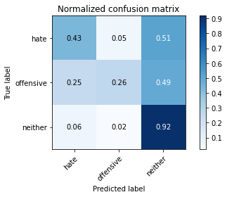

precision recall f1-score support

hate 0.58 0.43 0.50 773

offensive 0.55 0.26 0.35 430

neither 0.78 0.92 0.84 2329

accuracy 0.73 3532

macro avg 0.64 0.54 0.56 3532

weighted avg 0.71 0.73 0.71 3532

average eval_loss: 0.762303855964693, accuracy: 0.7324462061155153

training 4 epoch...

63.673556327819824 seconds used......

4 training finished! average train loss: 0.38867413682893

total clf loss: 49.010494228452444 total adv loss: 11.835784739931114

evaluating...

Confusion matrix, without normalization

[[ 310 80 383]

[ 64 159 207]

[ 124 90 2115]]

Normalized confusion matrix

[[0.40103493 0.10349288 0.49547219]

[0.14883721 0.36976744 0.48139535]

[0.05324173 0.03864319 0.90811507]]

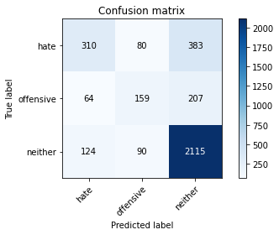

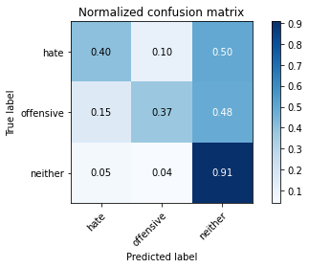

precision recall f1-score support

hate 0.62 0.40 0.49 773

offensive 0.48 0.37 0.42 430

neither 0.78 0.91 0.84 2329

accuracy 0.73 3532

macro avg 0.63 0.56 0.58 3532

weighted avg 0.71 0.73 0.71 3532

average eval_loss: 0.8522064189958034, accuracy: 0.7315968289920725

training 5 epoch...

63.76543211936951 seconds used......

5 training finished! average train loss: 0.24904187728855062

total clf loss: 31.966873585246503 total adv loss: 7.3019787632874795

evaluating...

Confusion matrix, without normalization

[[ 364 115 294]

[ 81 198 151]

[ 203 167 1959]]

Normalized confusion matrix

[[0.47089263 0.14877102 0.38033635]

[0.18837209 0.46046512 0.35116279]

[0.08716187 0.07170459 0.84113353]]

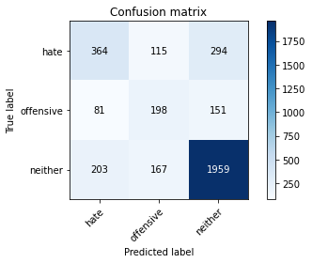

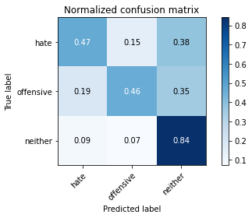

precision recall f1-score support

hate 0.56 0.47 0.51 773

offensive 0.41 0.46 0.44 430

neither 0.81 0.84 0.83 2329

accuracy 0.71 3532

macro avg 0.60 0.59 0.59 3532

weighted avg 0.71 0.71 0.71 3532

average eval_loss: 0.9236865939393555, accuracy: 0.7137599093997735

training 6 epoch...

63.87627291679382 seconds used......

6 training finished! average train loss: 0.154584251478673

total clf loss: 21.094997198320925 total adv loss: 3.9061289233577554

evaluating...

Confusion matrix, without normalization

[[ 331 91 351]

[ 81 165 184]

[ 153 106 2070]]

Normalized confusion matrix

[[0.42820181 0.11772316 0.45407503]

[0.18837209 0.38372093 0.42790698]

[0.06569343 0.0455131 0.88879347]]

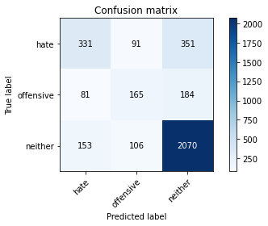

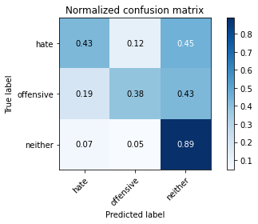

precision recall f1-score support

hate 0.59 0.43 0.49 773

offensive 0.46 0.38 0.42 430

neither 0.79 0.89 0.84 2329

accuracy 0.73 3532

macro avg 0.61 0.57 0.58 3532

weighted avg 0.71 0.73 0.71 3532

average eval_loss: 1.029818580943649, accuracy: 0.7265005662514157

training 7 epoch...

63.81944489479065 seconds used......

7 training finished! average train loss: 0.12260260947676187

total clf loss: 13.65467116702348 total adv loss: 4.636008339582986

evaluating...

Confusion matrix, without normalization

[[ 443 65 265]

[ 127 162 141]

[ 316 112 1901]]

Normalized confusion matrix

[[0.57309185 0.08408797 0.34282018]

[0.29534884 0.37674419 0.32790698]

[0.13568055 0.04808931 0.81623014]]

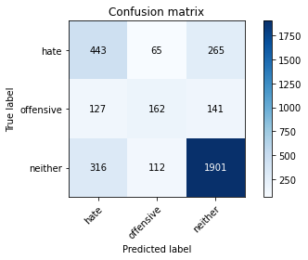

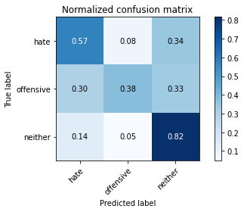

precision recall f1-score support

hate 0.50 0.57 0.53 773

offensive 0.48 0.38 0.42 430

neither 0.82 0.82 0.82 2329

accuracy 0.71 3532

macro avg 0.60 0.59 0.59 3532

weighted avg 0.71 0.71 0.71 3532

average eval_loss: 1.0857262780605736, accuracy: 0.7095130237825594

training 8 epoch...

63.79984450340271 seconds used......

8 training finished! average train loss: 0.07623559940247772

total clf loss: 10.229683701414615 total adv loss: 2.0131867110194435

evaluating...

Confusion matrix, without normalization

[[ 312 103 358]

[ 60 194 176]

[ 138 136 2055]]

Normalized confusion matrix

[[0.40362225 0.13324709 0.46313066]

[0.13953488 0.45116279 0.40930233]

[0.0592529 0.05839416 0.88235294]]

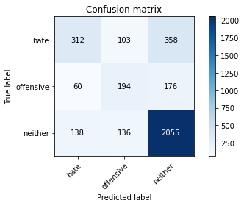

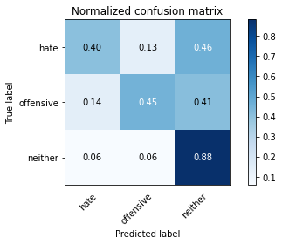

precision recall f1-score support

hate 0.61 0.40 0.49 773

offensive 0.45 0.45 0.45 430

neither 0.79 0.88 0.84 2329

accuracy 0.73 3532

macro avg 0.62 0.58 0.59 3532

weighted avg 0.71 0.73 0.71 3532

average eval_loss: 1.2330453276297466, accuracy: 0.7250849377123443

training 9 epoch...

63.75256657600403 seconds used......

9 training finished! average train loss: 0.04366508383617642

total clf loss: 5.736628991318867 total adv loss: 1.2143708510755005

evaluating...

Confusion matrix, without normalization

[[ 369 84 320]

[ 94 160 176]

[ 202 112 2015]]

Normalized confusion matrix

[[0.47736093 0.10866753 0.41397154]

[0.21860465 0.37209302 0.40930233]

[0.0867325 0.04808931 0.86517819]]

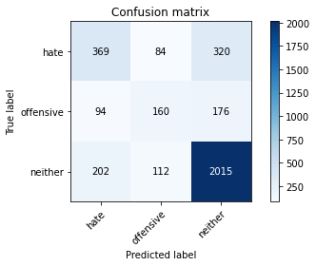

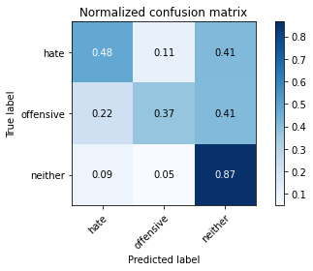

precision recall f1-score support

hate 0.55 0.48 0.51 773

offensive 0.45 0.37 0.41 430

neither 0.80 0.87 0.83 2329

accuracy 0.72 3532

macro avg 0.60 0.57 0.58 3532

weighted avg 0.71 0.72 0.71 3532

average eval_loss: 1.282635807191248, accuracy: 0.7202718006795017

training 10 epoch...

63.78695583343506 seconds used......

10 training finished! average train loss: 0.06369119654484293

total clf loss: 6.208497308078222 total adv loss: 2.850878285711815

evaluating...

Confusion matrix, without normalization

[[ 422 74 277]

[ 118 155 157]

[ 264 118 1947]]

Normalized confusion matrix

[[0.54592497 0.09573092 0.35834411]

[0.2744186 0.36046512 0.36511628]

[0.11335337 0.05066552 0.83598111]]

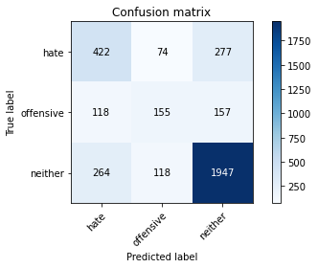

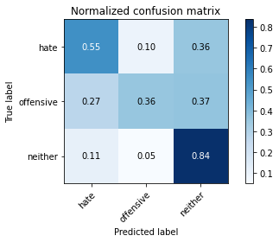

precision recall f1-score support

hate 0.52 0.55 0.54 773

offensive 0.45 0.36 0.40 430

neither 0.82 0.84 0.83 2329

accuracy 0.71 3532

macro avg 0.60 0.58 0.59 3532

weighted avg 0.71 0.71 0.71 3532

average eval_loss: 1.323221945198579, accuracy: 0.7146092865232163

4 run......

training 1 epoch...

63.77403664588928 seconds used......

1 training finished! average train loss: 1.730282542221049

total clf loss: 164.4604120850563 total adv loss: 79.55121181160212

evaluating...

Confusion matrix, without normalization

[[ 369 100 304]

[ 78 167 185]

[ 245 116 1968]]

Normalized confusion matrix

[[0.47736093 0.12936611 0.39327296]

[0.18139535 0.38837209 0.43023256]

[0.10519536 0.04980678 0.84499785]]

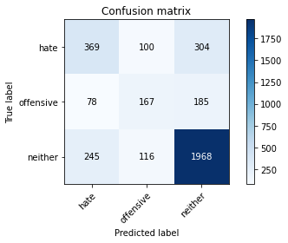

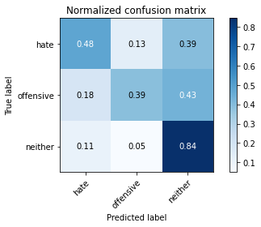

precision recall f1-score support

hate 0.53 0.48 0.50 773

offensive 0.44 0.39 0.41 430

neither 0.80 0.84 0.82 2329

accuracy 0.71 3532

macro avg 0.59 0.57 0.58 3532

weighted avg 0.70 0.71 0.70 3532

average eval_loss: 0.7209733948532471, accuracy: 0.7089467723669309

training 2 epoch...

63.77773070335388 seconds used......

2 training finished! average train loss: 1.2005223035812378

total clf loss: 113.04887321591377 total adv loss: 55.72439840063453

evaluating...

Confusion matrix, without normalization

[[ 233 90 450]

[ 47 162 221]

[ 61 74 2194]]

Normalized confusion matrix

[[0.30142303 0.1164295 0.58214748]

[0.10930233 0.37674419 0.51395349]

[0.0261915 0.03177329 0.94203521]]

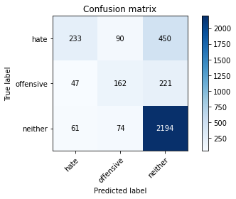

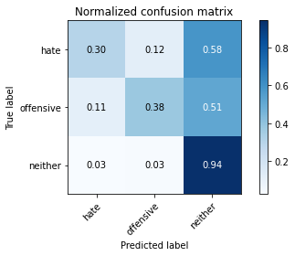

precision recall f1-score support

hate 0.68 0.30 0.42 773

offensive 0.50 0.38 0.43 430

neither 0.77 0.94 0.84 2329

accuracy 0.73 3532

macro avg 0.65 0.54 0.56 3532

weighted avg 0.72 0.73 0.70 3532

average eval_loss: 0.6847840523989187, accuracy: 0.7330124575311439

training 3 epoch...

63.780259132385254 seconds used......

3 training finished! average train loss: 0.7417882915167885

total clf loss: 76.68579666316509 total adv loss: 31.014306962955743

evaluating...

Confusion matrix, without normalization

[[ 302 79 392]

[ 73 158 199]

[ 115 79 2135]]

Normalized confusion matrix

[[0.39068564 0.10219922 0.50711514]

[0.16976744 0.36744186 0.4627907 ]

[0.04937742 0.03392014 0.91670245]]

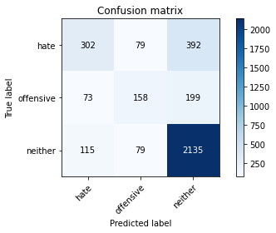

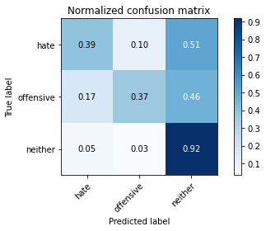

precision recall f1-score support

hate 0.62 0.39 0.48 773

offensive 0.50 0.37 0.42 430

neither 0.78 0.92 0.84 2329

accuracy 0.73 3532

macro avg 0.63 0.56 0.58 3532

weighted avg 0.71 0.73 0.71 3532

average eval_loss: 0.7565726021588859, accuracy: 0.7347112117780294

training 4 epoch...

63.8220272064209 seconds used......

4 training finished! average train loss: 0.3659919615097862

total clf loss: 46.80987937375903 total adv loss: 10.815308615507092

evaluating...

Confusion matrix, without normalization

[[ 364 92 317]

[ 96 161 173]

[ 220 108 2001]]

Normalized confusion matrix

[[0.47089263 0.11901682 0.41009056]

[0.22325581 0.3744186 0.40232558]

[0.09446114 0.04637183 0.85916702]]

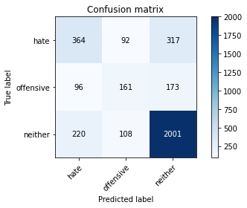

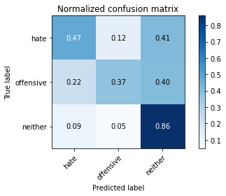

precision recall f1-score support

hate 0.54 0.47 0.50 773

offensive 0.45 0.37 0.41 430

neither 0.80 0.86 0.83 2329

accuracy 0.72 3532

macro avg 0.59 0.57 0.58 3532

weighted avg 0.70 0.72 0.71 3532

average eval_loss: 0.8382636967015131, accuracy: 0.7151755379388448

training 5 epoch...

63.79574799537659 seconds used......

5 training finished! average train loss: 0.2132013344310503

total clf loss: 30.000191627070308 total adv loss: 4.9342288835468935

evaluating...

Confusion matrix, without normalization

[[ 420 44 309]

[ 140 114 176]

[ 250 64 2015]]

Normalized confusion matrix

[[0.54333765 0.05692109 0.39974127]

[0.3255814 0.26511628 0.40930233]

[0.10734221 0.0274796 0.86517819]]

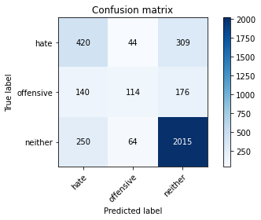

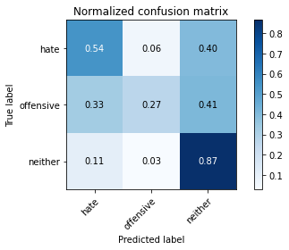

precision recall f1-score support

hate 0.52 0.54 0.53 773

offensive 0.51 0.27 0.35 430

neither 0.81 0.87 0.83 2329

accuracy 0.72 3532

macro avg 0.61 0.56 0.57 3532

weighted avg 0.71 0.72 0.71 3532

average eval_loss: 0.9511925701872778, accuracy: 0.7216874292185731

training 6 epoch...

63.772438049316406 seconds used......

6 training finished! average train loss: 0.15417180913575193

total clf loss: 20.18870476819575 total adv loss: 4.3207117935130555

evaluating...

Confusion matrix, without normalization

[[ 402 81 290]

[ 128 150 152]

[ 250 112 1967]]

Normalized confusion matrix

[[0.52005175 0.10478655 0.37516171]

[0.29767442 0.34883721 0.35348837]

[0.10734221 0.04808931 0.84456848]]

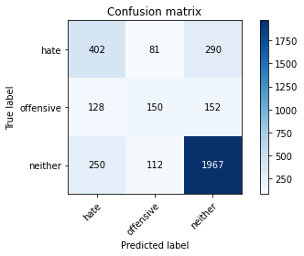

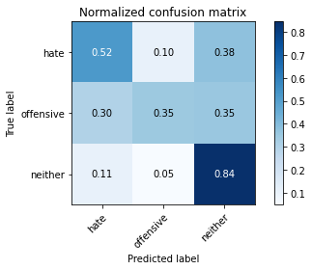

precision recall f1-score support

hate 0.52 0.52 0.52 773

offensive 0.44 0.35 0.39 430

neither 0.82 0.84 0.83 2329

accuracy 0.71 3532

macro avg 0.59 0.57 0.58 3532

weighted avg 0.70 0.71 0.71 3532

average eval_loss: 1.030330580001497, accuracy: 0.7131936579841449

training 7 epoch...

63.788769006729126 seconds used......

7 training finished! average train loss: 0.11683335670713275

total clf loss: 14.619072896428406 total adv loss: 3.6143825000108336

evaluating...

Confusion matrix, without normalization

[[ 404 78 291]

[ 118 151 161]

[ 261 93 1975]]

Normalized confusion matrix

[[0.52263907 0.10090556 0.37645537]

[0.2744186 0.35116279 0.3744186 ]

[0.11206526 0.0399313 0.84800343]]

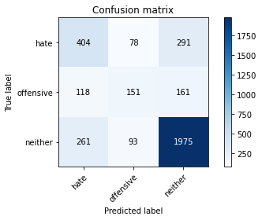

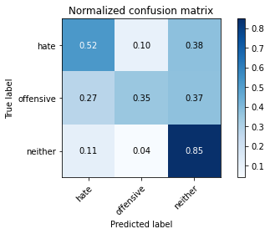

precision recall f1-score support

hate 0.52 0.52 0.52 773

offensive 0.47 0.35 0.40 430

neither 0.81 0.85 0.83 2329

accuracy 0.72 3532

macro avg 0.60 0.57 0.58 3532

weighted avg 0.71 0.72 0.71 3532

average eval_loss: 1.1435092424942275, accuracy: 0.7163080407701019

training 8 epoch...

63.75279498100281 seconds used......

8 training finished! average train loss: 0.07596805195677726

total clf loss: 8.360388787463307 total adv loss: 2.922818422147998

evaluating...

Confusion matrix, without normalization

[[ 350 97 326]

[ 81 172 177]

[ 184 102 2043]]

Normalized confusion matrix

[[0.45278137 0.12548512 0.42173351]

[0.18837209 0.4 0.41162791]

[0.07900386 0.04379562 0.87720052]]

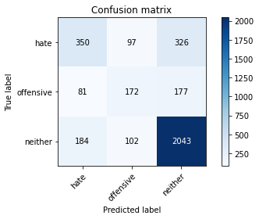

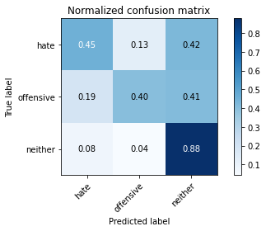

precision recall f1-score support

hate 0.57 0.45 0.50 773

offensive 0.46 0.40 0.43 430

neither 0.80 0.88 0.84 2329

accuracy 0.73 3532

macro avg 0.61 0.58 0.59 3532

weighted avg 0.71 0.73 0.72 3532

average eval_loss: 1.1786653662973878, accuracy: 0.7262174405436014

training 9 epoch...

63.739479303359985 seconds used......

9 training finished! average train loss: 0.05736108178790798

total clf loss: 6.39056076714769 total adv loss: 2.1679807599648484

evaluating...

Confusion matrix, without normalization

[[ 395 73 305]

[ 114 143 173]

[ 242 79 2008]]

Normalized confusion matrix

[[0.51099612 0.09443726 0.39456662]

[0.26511628 0.33255814 0.40232558]

[0.10390726 0.03392014 0.86217261]]

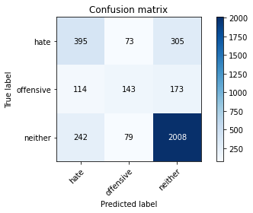

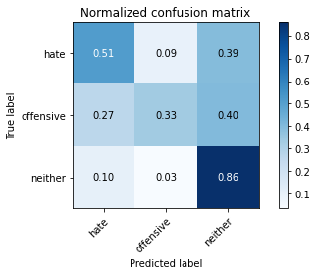

precision recall f1-score support

hate 0.53 0.51 0.52 773

offensive 0.48 0.33 0.39 430

neither 0.81 0.86 0.83 2329

accuracy 0.72 3532

macro avg 0.61 0.57 0.58 3532

weighted avg 0.71 0.72 0.71 3532

average eval_loss: 1.277203050710387, accuracy: 0.7208380520951302

training 10 epoch...

63.88604664802551 seconds used......

10 training finished! average train loss: 0.0319738593431847

total clf loss: 4.267251193756238 total adv loss: 0.8559302694459348

evaluating...

Confusion matrix, without normalization

[[ 387 92 294]

[ 95 169 166]

[ 214 107 2008]]

Normalized confusion matrix

[[0.50064683 0.11901682 0.38033635]

[0.22093023 0.39302326 0.38604651]

[0.09188493 0.04594246 0.86217261]]

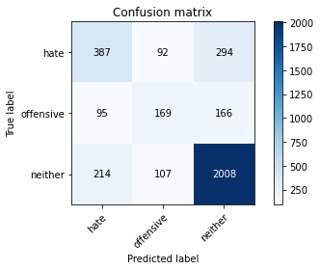

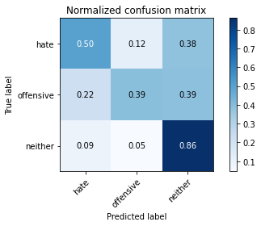

precision recall f1-score support

hate 0.56 0.50 0.53 773

offensive 0.46 0.39 0.42 430

neither 0.81 0.86 0.84 2329

accuracy 0.73 3532

macro avg 0.61 0.59 0.60 3532

weighted avg 0.71 0.73 0.72 3532

average eval_loss: 1.3033454571403353, accuracy: 0.7259343148357871

5 run......

training 1 epoch...

63.859487771987915 seconds used......

1 training finished! average train loss: 1.726561715258634

total clf loss: 163.79564726352692 total adv loss: 79.53569684922695

evaluating...

Confusion matrix, without normalization

[[ 282 72 419]

[ 78 131 221]

[ 132 67 2130]]

Normalized confusion matrix

[[0.36481242 0.0931436 0.54204398]

[0.18139535 0.30465116 0.51395349]

[0.05667669 0.02876771 0.9145556 ]]

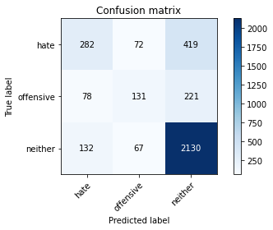

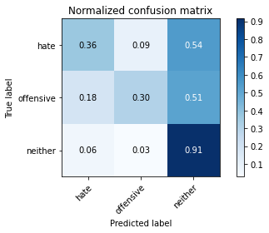

precision recall f1-score support

hate 0.57 0.36 0.45 773

offensive 0.49 0.30 0.37 430

neither 0.77 0.91 0.84 2329

accuracy 0.72 3532

macro avg 0.61 0.53 0.55 3532

weighted avg 0.69 0.72 0.69 3532

average eval_loss: 0.6927051028962863, accuracy: 0.7199886749716874

training 2 epoch...

63.79859256744385 seconds used......

2 training finished! average train loss: 1.202081439329341

total clf loss: 112.32342204451561 total adv loss: 56.232903108000755

evaluating...

Confusion matrix, without normalization

[[ 360 126 287]

[ 97 202 131]

[ 220 183 1926]]

Normalized confusion matrix

[[0.46571798 0.16300129 0.37128072]

[0.2255814 0.46976744 0.30465116]

[0.09446114 0.0785745 0.82696436]]

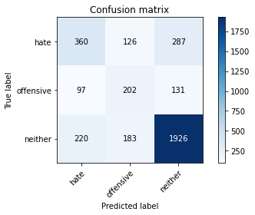

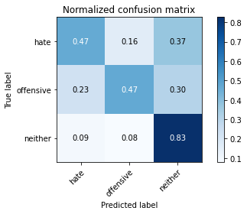

precision recall f1-score support

hate 0.53 0.47 0.50 773

offensive 0.40 0.47 0.43 430

neither 0.82 0.83 0.82 2329

accuracy 0.70 3532

macro avg 0.58 0.59 0.58 3532

weighted avg 0.71 0.70 0.70 3532

average eval_loss: 0.7052490013299015, accuracy: 0.7044167610419027

training 3 epoch...

63.738264322280884 seconds used......

3 training finished! average train loss: 0.7607022593206263

total clf loss: 77.45671650767326 total adv loss: 32.39730315096676

evaluating...

Confusion matrix, without normalization

[[ 248 78 447]

[ 53 153 224]

[ 72 66 2191]]

Normalized confusion matrix

[[0.32082794 0.10090556 0.57826649]

[0.12325581 0.35581395 0.52093023]

[0.03091456 0.02833834 0.9407471 ]]

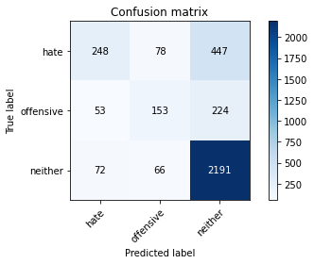

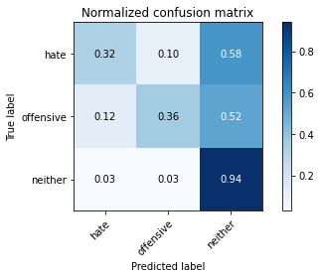

precision recall f1-score support

hate 0.66 0.32 0.43 773

offensive 0.52 0.36 0.42 430

neither 0.77 0.94 0.84 2329

accuracy 0.73 3532

macro avg 0.65 0.54 0.57 3532

weighted avg 0.71 0.73 0.70 3532

average eval_loss: 0.774602151944139, accuracy: 0.7338618346545867

training 4 epoch...

63.75334572792053 seconds used......

4 training finished! average train loss: 0.39996051055224824

total clf loss: 48.927361220121384 total adv loss: 12.932627139263786

evaluating...

Confusion matrix, without normalization

[[ 340 124 309]

[ 74 194 162]

[ 194 164 1971]]

Normalized confusion matrix

[[0.43984476 0.16041397 0.39974127]

[0.17209302 0.45116279 0.37674419]

[0.08329755 0.07041649 0.84628596]]

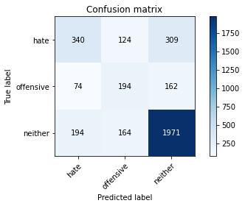

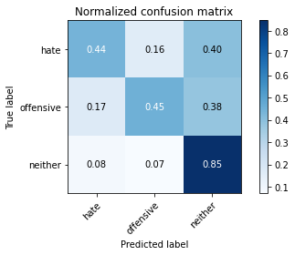

precision recall f1-score support

hate 0.56 0.44 0.49 773

offensive 0.40 0.45 0.43 430

neither 0.81 0.85 0.83 2329

accuracy 0.71 3532

macro avg 0.59 0.58 0.58 3532

weighted avg 0.70 0.71 0.70 3532

average eval_loss: 0.8373802486112563, accuracy: 0.7092298980747452

training 5 epoch...

63.83924579620361 seconds used......

5 training finished! average train loss: 0.20866519645015824

total clf loss: 31.484454963356256 total adv loss: 3.7679683307051164

evaluating...

Confusion matrix, without normalization

[[ 417 126 230]

[ 97 205 128]

[ 308 197 1824]]

Normalized confusion matrix

[[0.53945666 0.16300129 0.29754204]

[0.2255814 0.47674419 0.29767442]

[0.1322456 0.08458566 0.78316874]]

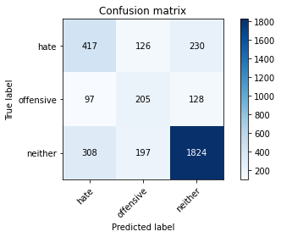

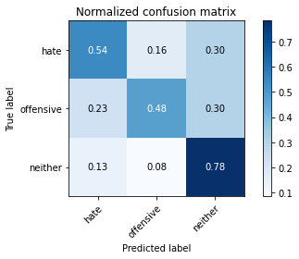

precision recall f1-score support

hate 0.51 0.54 0.52 773

offensive 0.39 0.48 0.43 430

neither 0.84 0.78 0.81 2329

accuracy 0.69 3532

macro avg 0.58 0.60 0.59 3532

weighted avg 0.71 0.69 0.70 3532

average eval_loss: 0.9655462941207454, accuracy: 0.6925254813137033

training 6 epoch...

63.761539697647095 seconds used......

6 training finished! average train loss: 0.13872178686772757

total clf loss: 19.952140658628196 total adv loss: 2.9944167936009762

evaluating...

Confusion matrix, without normalization

[[ 357 87 329]

[ 98 138 194]

[ 187 85 2057]]

Normalized confusion matrix

[[0.461837 0.11254851 0.42561449]

[0.22790698 0.32093023 0.45116279]

[0.08029197 0.03649635 0.88321168]]

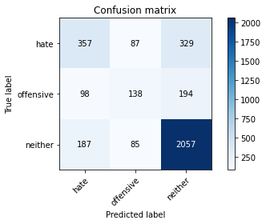

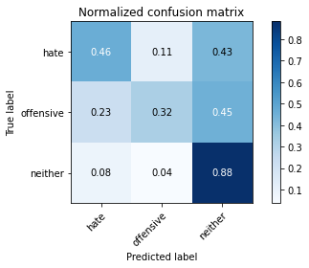

precision recall f1-score support

hate 0.56 0.46 0.50 773

offensive 0.45 0.32 0.37 430

neither 0.80 0.88 0.84 2329

accuracy 0.72 3532

macro avg 0.60 0.56 0.57 3532

weighted avg 0.70 0.72 0.71 3532

average eval_loss: 1.0543801888907696, accuracy: 0.7225368063420159

training 7 epoch...

63.79100942611694 seconds used......

7 training finished! average train loss: 0.09335614828253413

total clf loss: 13.72938738297671 total adv loss: 1.8641061997650468

evaluating...

Confusion matrix, without normalization

[[ 338 100 335]

[ 81 164 185]

[ 176 105 2048]]

Normalized confusion matrix

[[0.43725744 0.12936611 0.43337646]

[0.18837209 0.38139535 0.43023256]

[0.07556891 0.04508373 0.87934736]]

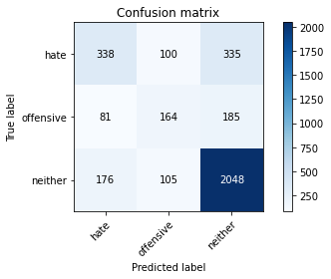

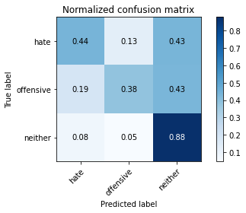

precision recall f1-score support

hate 0.57 0.44 0.49 773

offensive 0.44 0.38 0.41 430

neither 0.80 0.88 0.84 2329

accuracy 0.72 3532

macro avg 0.60 0.57 0.58 3532

weighted avg 0.70 0.72 0.71 3532

average eval_loss: 1.1710651328755637, accuracy: 0.7219705549263873

training 8 epoch...

63.828341007232666 seconds used......

8 training finished! average train loss: 0.07157318864047607

total clf loss: 8.785781077574939 total adv loss: 2.2992026224810616

evaluating...

Confusion matrix, without normalization

[[ 346 69 358]

[ 91 142 197]

[ 163 75 2091]]

Normalized confusion matrix

[[0.44760673 0.08926261 0.46313066]

[0.21162791 0.33023256 0.45813953]

[0.06998712 0.03220266 0.89781022]]

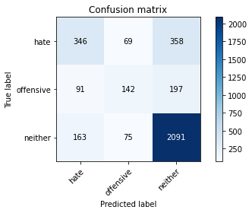

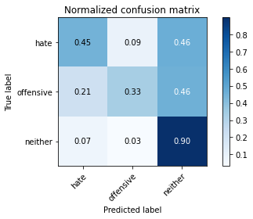

precision recall f1-score support

hate 0.58 0.45 0.50 773

offensive 0.50 0.33 0.40 430

neither 0.79 0.90 0.84 2329

accuracy 0.73 3532

macro avg 0.62 0.56 0.58 3532

weighted avg 0.71 0.73 0.71 3532

average eval_loss: 1.2517850422589791, accuracy: 0.7301812004530012

training 9 epoch...

63.73858308792114 seconds used......

9 training finished! average train loss: 0.07784474657146251

total clf loss: 7.252916072262451 total adv loss: 3.6520257282954844

evaluating...

Confusion matrix, without normalization

[[ 402 61 310]

[ 130 132 168]

[ 235 83 2011]]

Normalized confusion matrix

[[0.52005175 0.07891332 0.40103493]

[0.30232558 0.30697674 0.39069767]

[0.10090167 0.03563761 0.86346071]]

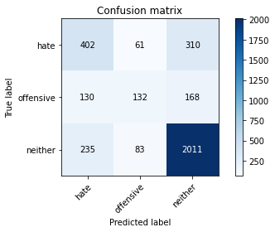

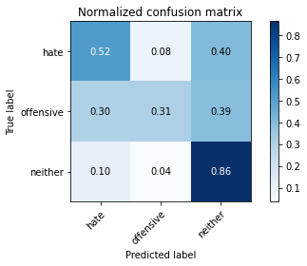

precision recall f1-score support

hate 0.52 0.52 0.52 773

offensive 0.48 0.31 0.37 430

neither 0.81 0.86 0.83 2329

accuracy 0.72 3532

macro avg 0.60 0.56 0.58 3532

weighted avg 0.71 0.72 0.71 3532

average eval_loss: 1.274785520750924, accuracy: 0.720554926387316

training 10 epoch...

63.76212120056152 seconds used......

10 training finished! average train loss: 0.04015278027244759

total clf loss: 4.495570300496183 total adv loss: 1.5064998048235054

evaluating...

Confusion matrix, without normalization

[[ 356 86 331]

[ 87 152 191]

[ 176 102 2051]]

Normalized confusion matrix

[[0.46054334 0.11125485 0.42820181]

[0.20232558 0.35348837 0.44418605]

[0.07556891 0.04379562 0.88063547]]

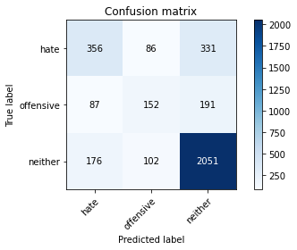

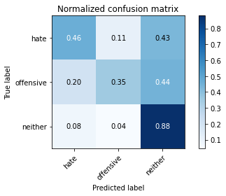

precision recall f1-score support

hate 0.58 0.46 0.51 773

offensive 0.45 0.35 0.39 430

neither 0.80 0.88 0.84 2329

accuracy 0.72 3532

macro avg 0.61 0.56 0.58 3532

weighted avg 0.71 0.72 0.71 3532

average eval_loss: 1.387372176483863, accuracy: 0.7245186862967158